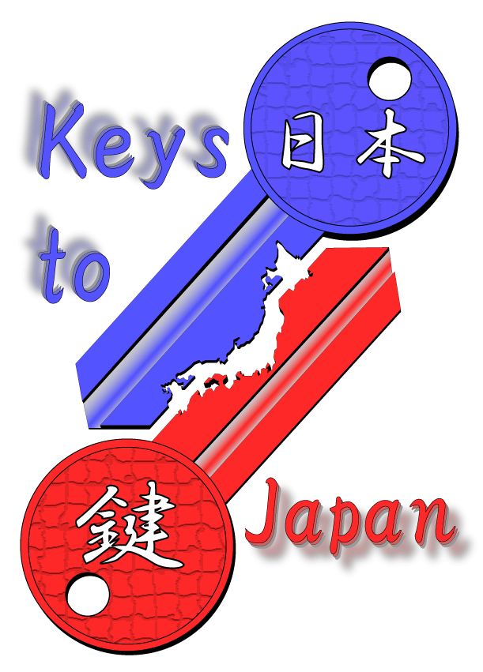

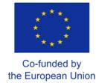

“Keys to Japan”:
Sponsored market entry plans for Japan
“Keys to Japan” supports European SMEs with a sponsorship worth approx. € 10,000 for the draft of a market entry plan in Japan through a competition, which will be awarded to the best application submitted in 2023-2024 (notes [1], [2]).

The market entry plan will be delivered by the Japan Market Expansion Competition (JMEC).

Who is eligible to apply?
Applicants must be nationals from a member country of the EU/COSME working in a management position for a European Small and Medium Entreprise (SME) headquartered in the EU/COSME zone. Applicants must be at least 20 years of age at the date of submission of the application form.
Valid applications will be ranked against the quality and coherence of the draft, value of their product/service/solution, justification and interest to enter the Japanese market, potential for successful market entry of the product / services, and possible risks and challenges in Japan.

How to apply
To qualify for the competition, applicants must complete and submit the filled form to:
KeysToJapan@eu-japan.or.jp by Monday 3 July 2023, 17h30 Tokyo local time.
For any questions about “Keys to Japan” or how to fill in this form, contact the EU-Japan Centre for Industrial Cooperation (Fabrizio Mura tel: +81 (0)3 6408 0281 e-mail: KeysToJapan@eu-japan.or.jp)

Applicant’s profile and description of the company
(All fields are mandatory - All information filled in the form will be treated confidentially and for internal use only)

Company Name |  | City |  |  | Country
Street |  |  |  |  | Postal Code
www address |  | Full Name of Contact Person (“the applicant”)
Position in the company |  | Telephone |  |  | Fax
 |  |  | E-mail of the Contact Person
Year established:
Turnover in million Euro: |  | Size and type of organization:
< 1 million 1 to 10 |  | Industry: < 10 employees
10 to 20 20 to 50 |  | Industry: 10 – 49
50 to 100 100 to 250 |  | Industry: 50 – 249
250 to 500 > 500 Million

Briefly describe the product or service which your company wishes to introduce in Japan
Indicate clearly the type of product or service which your company is considering to market in Japan.  Describe the unique and innovative aspects, economic advantages/benefits of your product/service.  Explain your company’s market experience in Japan: are you are marketing this product/service for the first time in Japan?  Briefly describe your company’s interest and history of success in entering markets in Asia, Africa and/or Latin America for similar products / services.  The product/service which you describe must be manufactured, produced or developed by your company. | (maximum 200 words)

Explain why you believe your company should be sponsored by “Keys to Japan”
Explain why your company is interested in entering or expanding in the Japanese Market.  Explain why your products / service would appeal to potential Japanese customers.  Provide additional product information (copy/paste pictures) or supply a URL which describes the product/service, possibly with a catalog.  Describe the possible risks and challenges your product/service could face in the Japanese market. | (maximum 200 words)

Check this box to agree to the terms of application: □

“By submitting this form, applicants declare that the information provided herein is accurate and correct. Incomplete application forms, omissions or mistakes in the information provided by the applicant will result in an invalid application and will not be entered in the sponsorship competition. Duly completed application forms will receive an acknowledgement of registration, which validates their entry to the competition for the sponsorship under Keys to Japan.

Furthermore, applicants who are selected to win the Keys to Japan competition pledge to actively contribute with their time and commit resources to supply information at the request of the team in charge of preparing the market entry business plan”.

Check this box to receive information on future calls of Keys To Japan □

Check this box to receive the EU-Japan Quarterly Newsletter □
To qualify for the competition, applicants must complete and submit the filled form to: KeysToJapan@eu-japan.or.jp by Monday 3 July 2022, 17h30 Tokyo local time.
For any questions about “Keys to Japan” or how to fill in this form, contact the EU-Japan Centre for Industrial Cooperation (Fabrizio Mura tel: +81 (0)3 6408 0281 e-mail: KeysToJapan@eu-japan.or.jp).
Refer to the following Disclaimer, Confidentialities and Copyright Clauses at:
http://www.eu-japan.eu/market-entry-business-plan-support-keys-japan

